**Color Palettes**

*Goth Dating App*

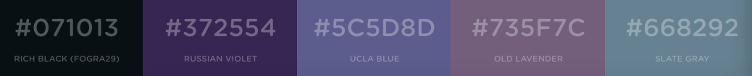

Colors were chosen because they have a “goth” feel

* Rich Black (Fogra29) #071013 – font
* Russian Violet #372554 – link
* UCLA Blue #5C5D8D – background
* Old Lavender #735F7C – borders
* Slate Gray #668292 – buttons

*Rare Newspaper Collecting App*

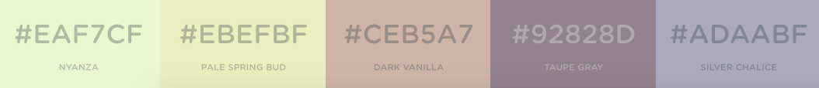

Colors were chosen to look like old, yellowed newspapers and sepia photos

* Nyanza #EAF7CF – alternate background
* Pale Spring Bud #EBEFBF – background
* Dark Vanilla #CEB5A7 – link
* Taupe Gray #92828D – font
* Silver Chalice #ADAABF – borders

*Massachusetts Tourism App*

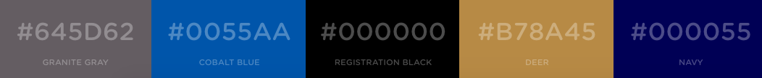

Colors were chosen from the Massachusetts state emblem

* Granite Gray #645D62 – borders
* Cobalt Blue #0055AA – links
* Registration Black #000000 – font
* Deer #B78A45 – background
* Navy #000055 – buttons

*Lucky Charms App*



Colors were selected from the Lucky Charms cereal box colors

* Nadeshiko Pink #EFB0C2 – alerts
* Mustard #FCD758 – button
* Shamrock Green #1B9E5E – background
* Ball Blue #34B3D3 – button
* Lilac #C2ACC6 – link

*NASA App*



Colors were chosen from the official NASA emblem

* Dark Pastel Blue #78A0CD – link
* White #FFFFFF – background
* Green-Blue #1A5FAC – button
* Dark Cerulean #004080 – font
* Red (Pantone) #EC2941 – alerts

*My Personal Brand*

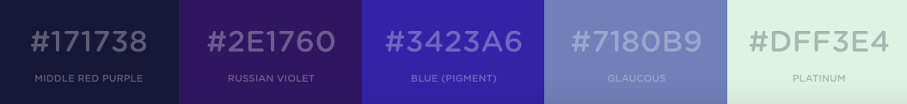

Colors were chosen from my personal preferences

* Middle Red Purple #171738 – font
* Russian Violet #2E1760 – button (activated)
* Blue (Pigment) #3423A6 – link
* Glaucous #7180B9 – button (inactive)
* Platinum #DFF3E4 – backgroundd